J-Tag Connection Revision

Objective
The purpose of this document is to document the process of revising the J-Tag connector circuit for software integration.

Specifications
- Connector Header Surface Mount 10 position 0.050" (1.27mm) Digikey
- Segger J-Link EDU Mini

Solution
The initial board design (QORVO_RADIO2_REV0) utilized the following footprint layout for the 10 position header.
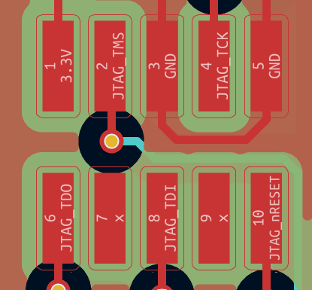
Figure 1: QORVO_RADIO2_REV0 J-Link Connector Header Footprint

This footprint layout did not match the pinout for the J-Link EDU mini as referenced in the figure below.
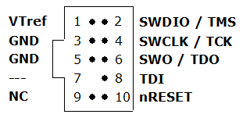
Figure 2: Segger J-Link EDU Mini Connector Pinout

This footprint was revised in QORVO_RADIO2_REV1 as shown below.
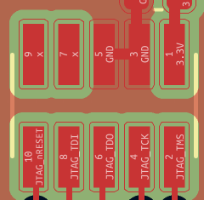
Figure 3: QORVO_RADIO2_REV1 J-Link Connector Header Footprint

After ordering QORVO_RADIO2_REV1, an issue with the QPG6200L pinout for programming was found. The GPIO5/PROG_ENn pin, utilized to put the QPG6200L into program mode, was left unconnected “floating” state. This pin must be in a low state to enable “programming mode”.
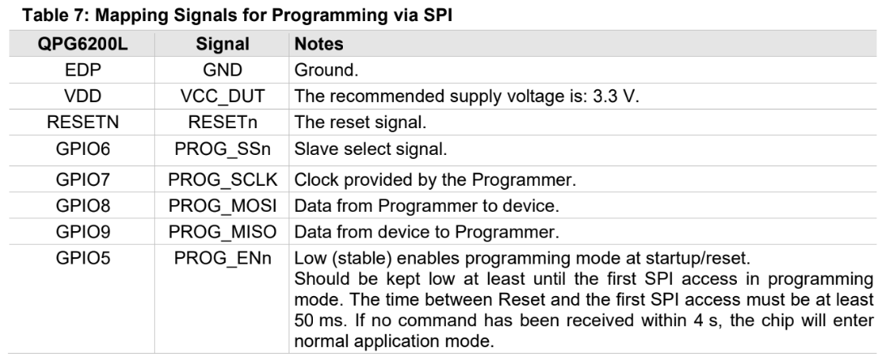
Figure 4: QPG6200L datasheet Table 7

A switch and a 1kΩ resistor will be connected in series between GND and the QPG6200L GPIO5 pin. Pad’s for two 0603 components will be placed in parallel with the switch and resistor in case the circuit needs bypassing.

